**DoubleTree by Hilton Denver-Aurora** | 13696 E. Iliff Place | Aurora, CO  80014

**Tel: 1-303-337-2800**

**Fax:  1-303-752-0296**

Location of this property is under 3 miles from the Colorado Rural Health Center and includes Complementary Airport Shuttle to the Denver International Airport. Special arrangements may be made for shuttle service to the CRHC office.

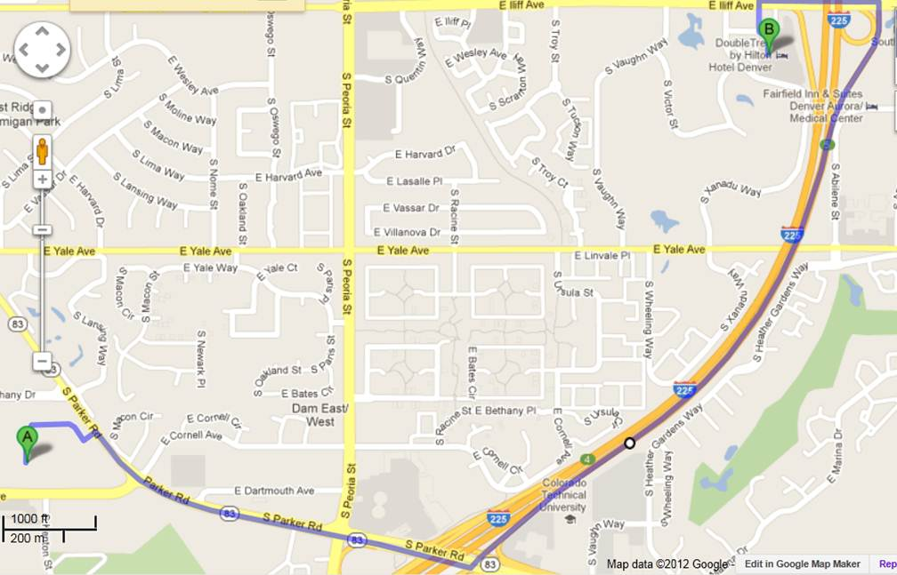

Aurora **DoubleTree** rate is **$134.00/nt** for stays in 2020.  This rate includes high speed internet connection and complimentary parking.  CRHC’s tax exempt information on file at this hotel, so taxes should not be added to room rate when the stay is business related **and paid for** by CRHC.  Prior to making payment for the stay, guests may need to remind the desk agent of CRHC’s tax exempt status and that the tax exempt paperwork is on file with the hotel.

[**https://secure3.hilton.com/en_US/dt/reservation/book.htm?ctyhocn=DENITDT&corporateCode=2770062**](https://secure3.hilton.com/en_US/dt/reservation/book.htm?ctyhocn=DENITDT&corporateCode=2770062)links you to a reservation page that automatically includes CRHC account number **0002770062**.

**Copy and paste the link into your browser if it doesn’t find the hotel immediately.**

Contact Rachel Williams ([rwilliams@coruralhealth.org](mailto:rwilliams@coruralhealth.org)) with any issues finding the account page.